Celebrating the Year of the Nurse
Self-Care Collection
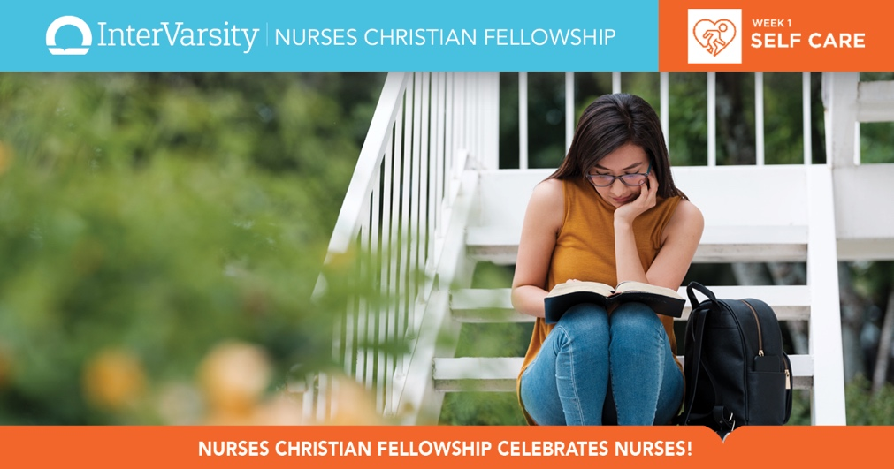

Bible Studies

Self-Care During COVID-19

Dealing with Depression

NCF Blog Posts:

Safety in God in the Time of Coronavirus

Choosing the Pain that Heals

Loneliness & the Love of Christ

Shalom: A Toast to Health

Give Thanks, Get Healthy

Beating Burnout, Jesus Style

How Are You Feeling?

Reviving Your Quiet Time

Hope and Disappointment

Thirsty? Assess Your Spiritual Hydration

Finding Comfort in God's Care

JCN Articles:

Self-Care: A Stewardship Perspective

Employee Spiritual Care: Supporting Those Who Care for Others

Clinical Nurse Specialist Perceptions' of Spiritual Care: Nurses Need Support, Care Falls Short

Nursing on Empty: Compassion Fatigue Signs, Symptoms, and System Interventions

Engaging Faith for Spiritual Fitness: Helping New Nurses Avoid Burnout

