Celebrating the Year of the Nurse
Recognition Collection

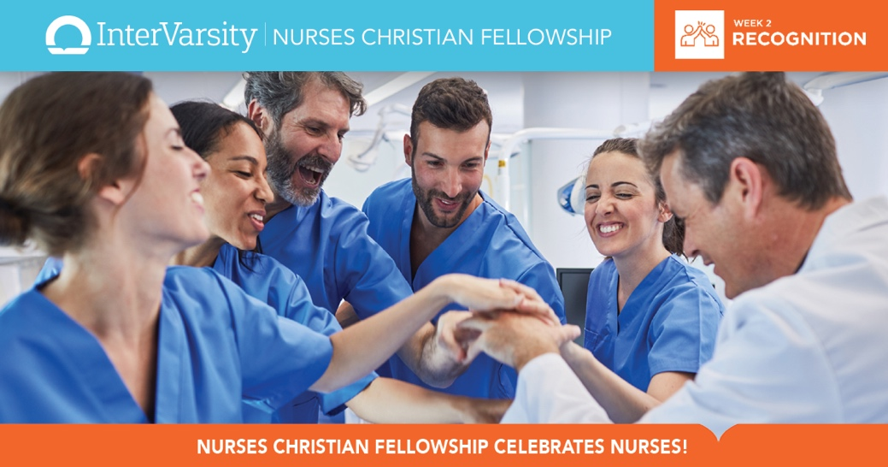

Bible Studies

Recognizing Our Calling and Identity in Christ

NCF Blog Posts:

Winning a DAISY Award: A God Story

Nurse's Calling is Connecting

The Spirit of Veterans Day

JCN Articles:

Authentic Leadership: Practices to Promote Integrity

Navigating Nursing Transitions: Joy in the Journey?

Magnet Recognition: The Rush Experience

