Celebrating the Year of the Nurse
Professional Development Collection

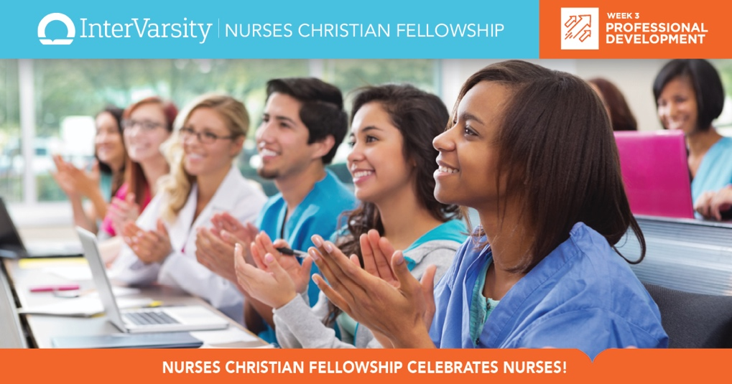

Bible Studies

Professional Development – Let Your Light Shine

Following Christ in Nursing

Applying the Bible to Nursing

NCF Blog Posts:

Becoming a Christian Nurse

Transitioning? God Has You.

Spiritual Answers for Incivility

10 Tips for 12-Hour Shifts

Mental Health: Talk to Me!

The Power of a Nurse’s Prayers

Facing a Crisis of Conscience

Avoiding Research "Sins"

Ethical Dilemma: Spiritual Care

Nursing: Messy, Tangled Grace

Intersection of Faith and Passion

A Good Word

When a Nursing Student Prays

Discerning Divine Appointments

JCN Articles:

Confronting Incivility in the Online Classroom

Promoting Ethical Development in Nursing Education and Beyond

Practicing the Code of Ethics, Finding the Image of God

Service-Learning and Interprofessional Education in Nursing: A Critical Need

Reciprocal Service-Learning Benefits Students, Educators, and the University

NursingCenter Resources & CE Discount Code

