Celebrating the Year of the Nurse
Community Engagement Collection

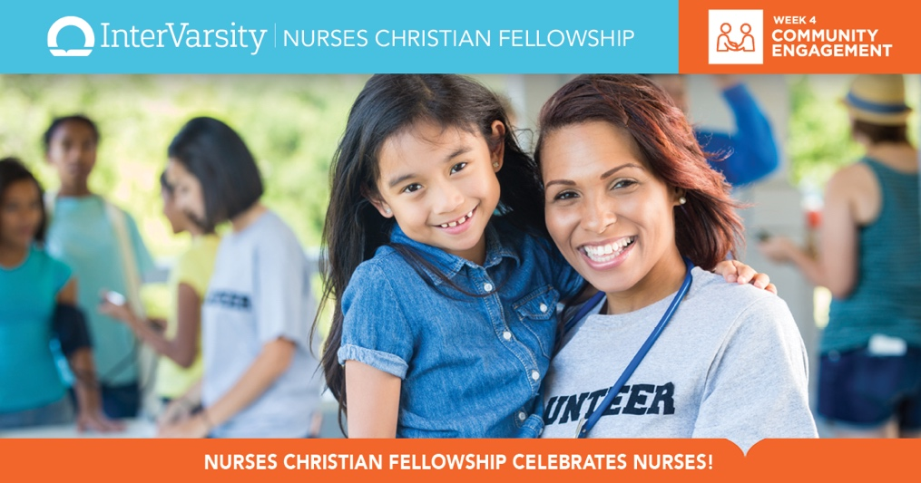

Bible Studies

Community Engagement: It’s About Relationships!

The Love We Have to Give

Healing Encounters with Jesus

NCF Blog Posts:

Winning a DAISY Award: A God Story

Nurse's Calling is Connecting

Nurses Bless Nurses Down South

Are My Neighbors Healthy?

Prayer Reaps Results on Campus

Walking Together at Baylor

Lunch with Pete

Being the Light

Mission to Appalachia

Nurses Branch Out

JCN Articles:

Promoting Successful Aging Through Faith Community Nursing

A Community Respite Ministry/University Partnership Creates Meaningful Elder-Care Experiences

A Congregation Transition of Care Program Using Faith Community Nurses and Volunteer Faith-Based Nurses

The Role of the Faith Community Nurse in Weight Management

Welcome Day: A Community Interprofessional Model for Meeting the Needs of Migrant Workers

Hypertension in the Faith Community: A Four-Week, Nurse Led, Diet/Exercise Intervention

Collaboration in the Gap: A New Day for Faith Community Nursing

Faith Community Nurses & Brown Bag Events Help Older Adults Manage Meds

Small-Scale Sustainable Water Project Decreases Infections, Complements Short-Term Medical Missions

